Q6.

#include<stdlib.h> //leap year

#include<stdio.h>

int main()

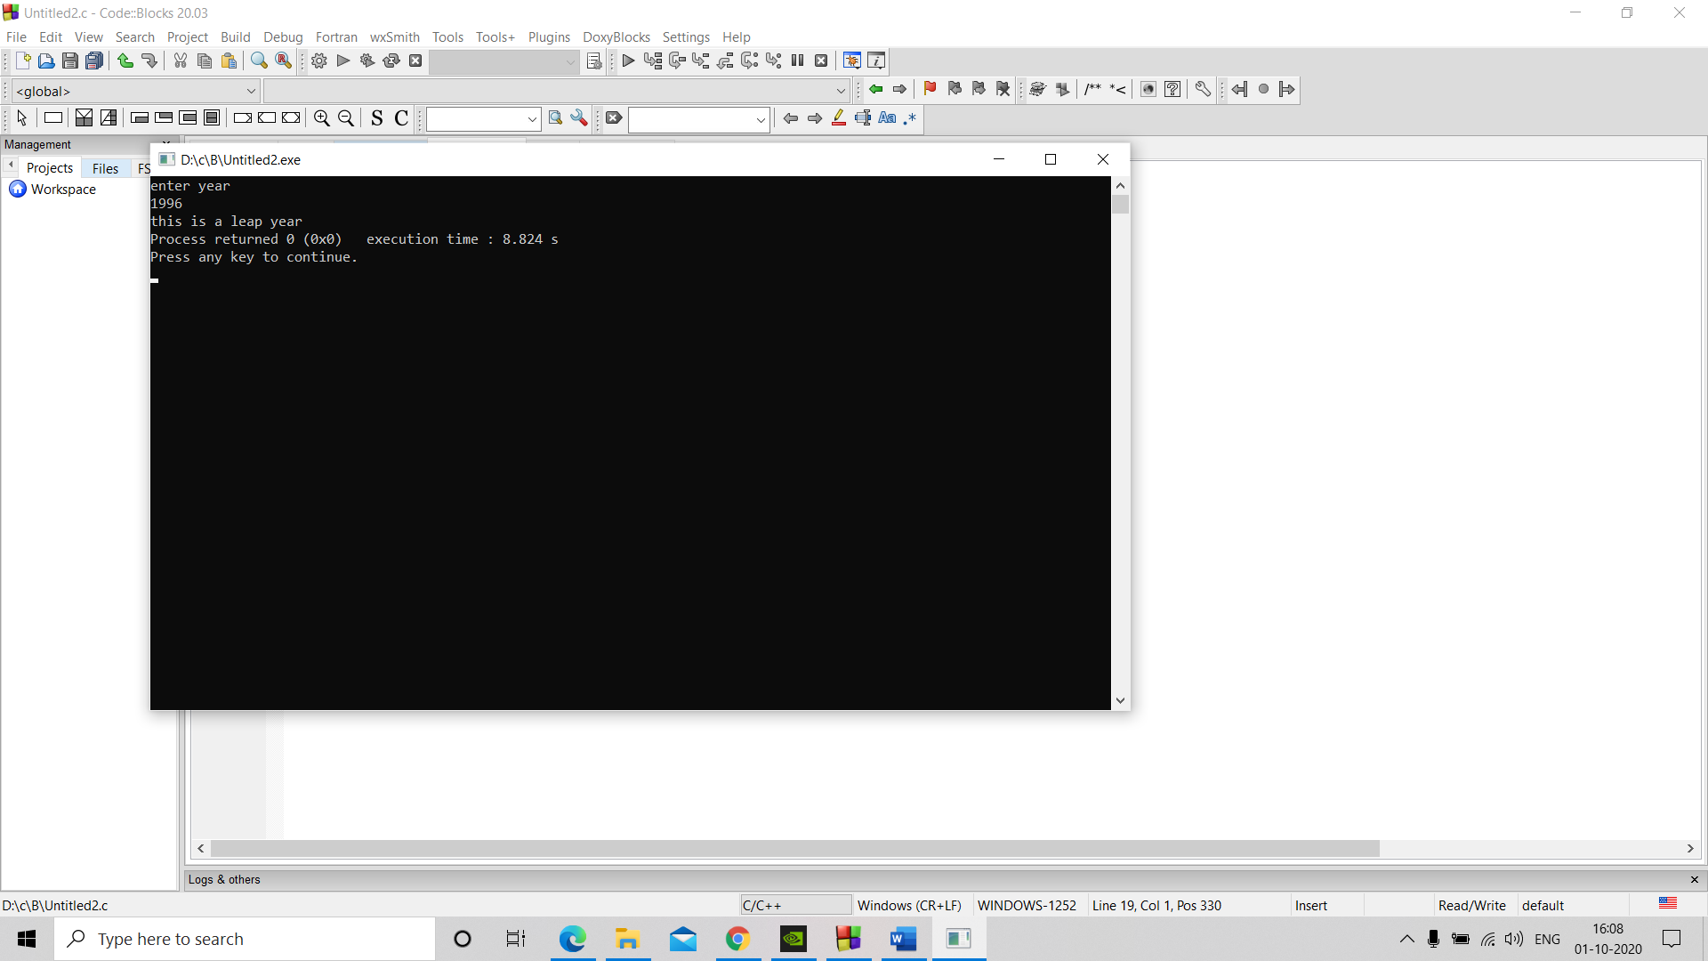{

int a;

printf("enter year \n");

scanf("%d",&a);

if(a>999 && a<10000)

{

if((a%4==0 && a%100!=0) || a%400==0)

printf("this is a leap year");

else

printf("this is not a leap year");

}

else

printf("invalid input");

}

Q7. #include<stdio.h> //largest among 3 nos.

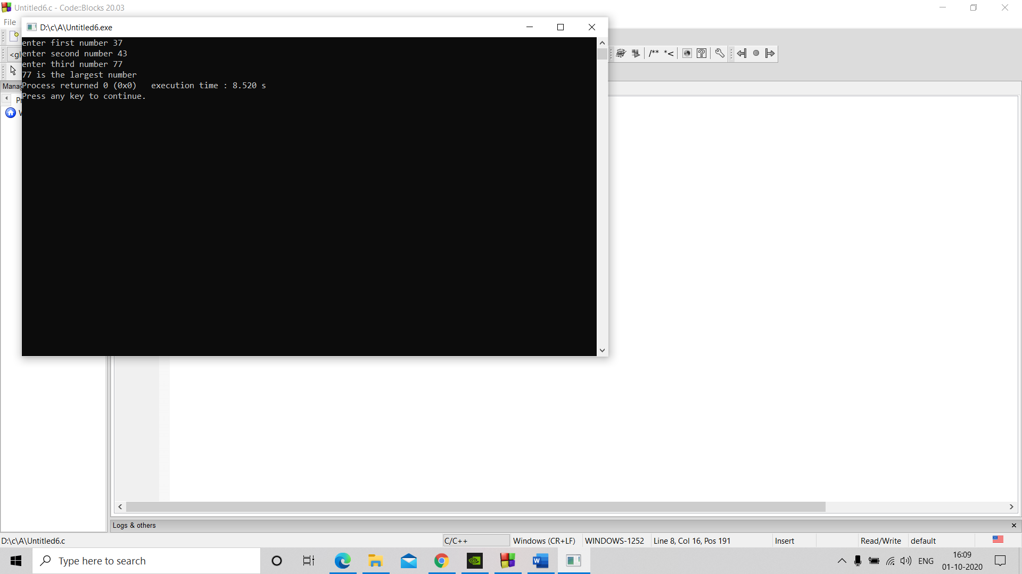#include<stdlib.h>

int main()

{int a,b,c;

printf("enter first number ");

scanf("%d",&a);

printf("enter second number ");

scanf("%d",&b);

printf("enter third number ");

scanf("%d",&c);

if(a>b)

{if(c>a)

printf("%d is the largest number",c);

else

printf("%d is the largest number",a);

}

else if(b>c)

printf("%d is the largest number",b);

else printf("%d is the largest number",c);

}

Q8. #include<stdlib.h> //grade

#include<stdio.h>

int main()

{

float a,b,c,d,e,p;

printf("enter your marks in English Computer Hindi Maths Science out of 100 \n");

scanf("%f %f %f %f %f ",&a,&b,&c,&d,&e);

p=(a+b+c+d+e)/5;

printf("percentage: %f \n",p);

if(p>=90)

printf("Grade A");

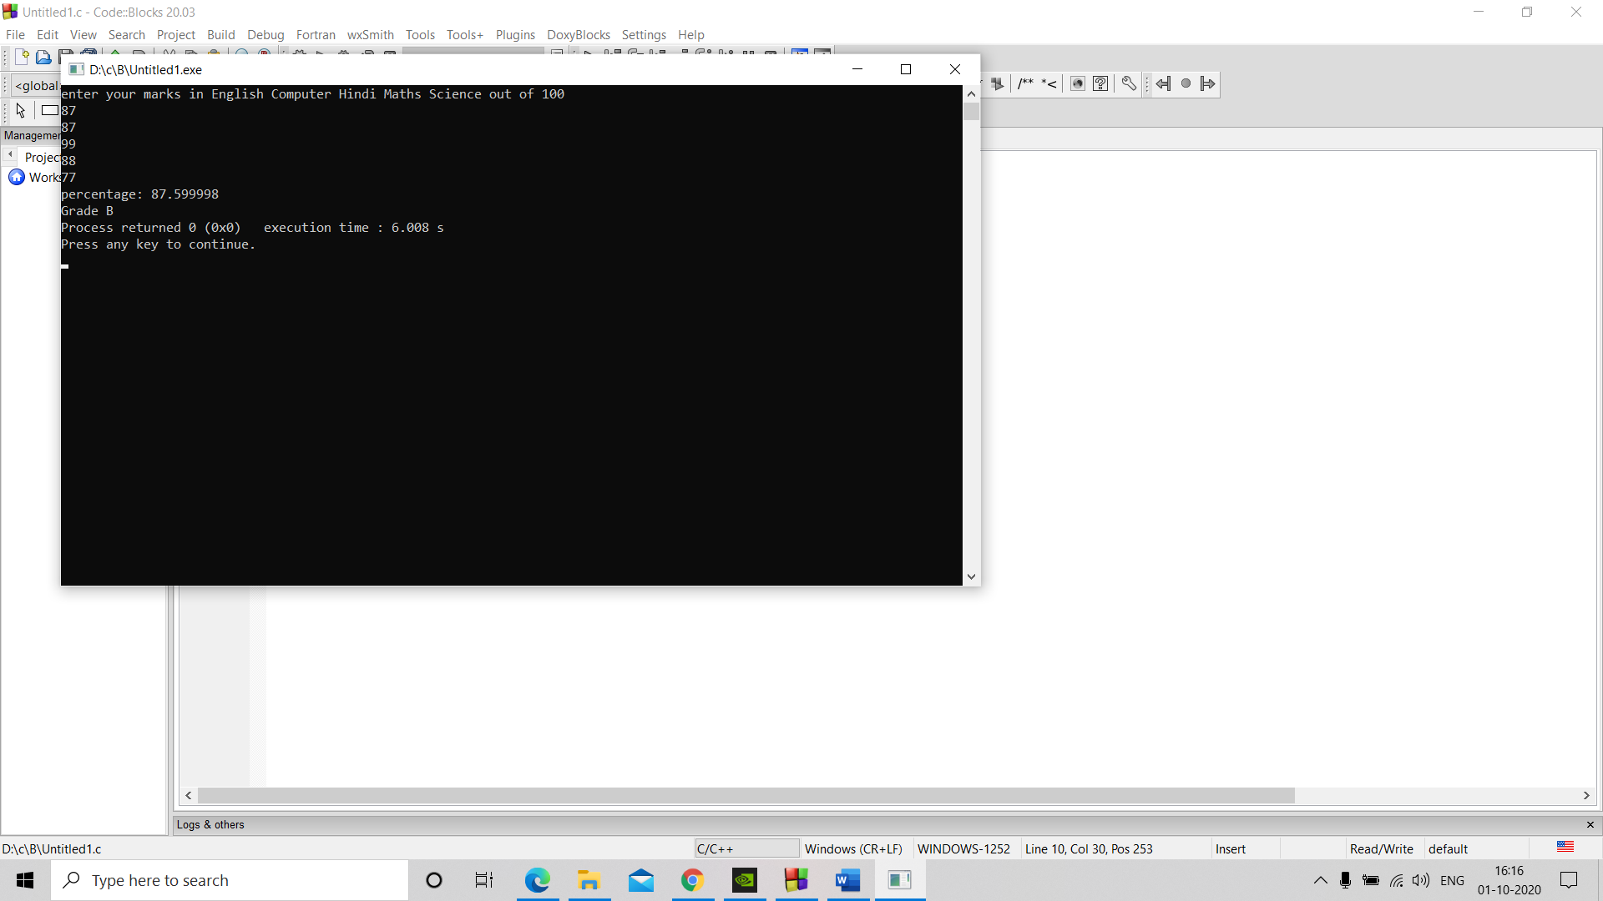else if(p>=80)

printf("Grade B");

else if(p>=70)

printf("Grade C");

else if(p>=60)

printf("Grade D");

else if(p>=40)

printf("Grade E");

else if(p<40)

printf("Grade F");

}

Q9. #include<stdlib.h> //denomination

#include<stdio.h>

int main()

{

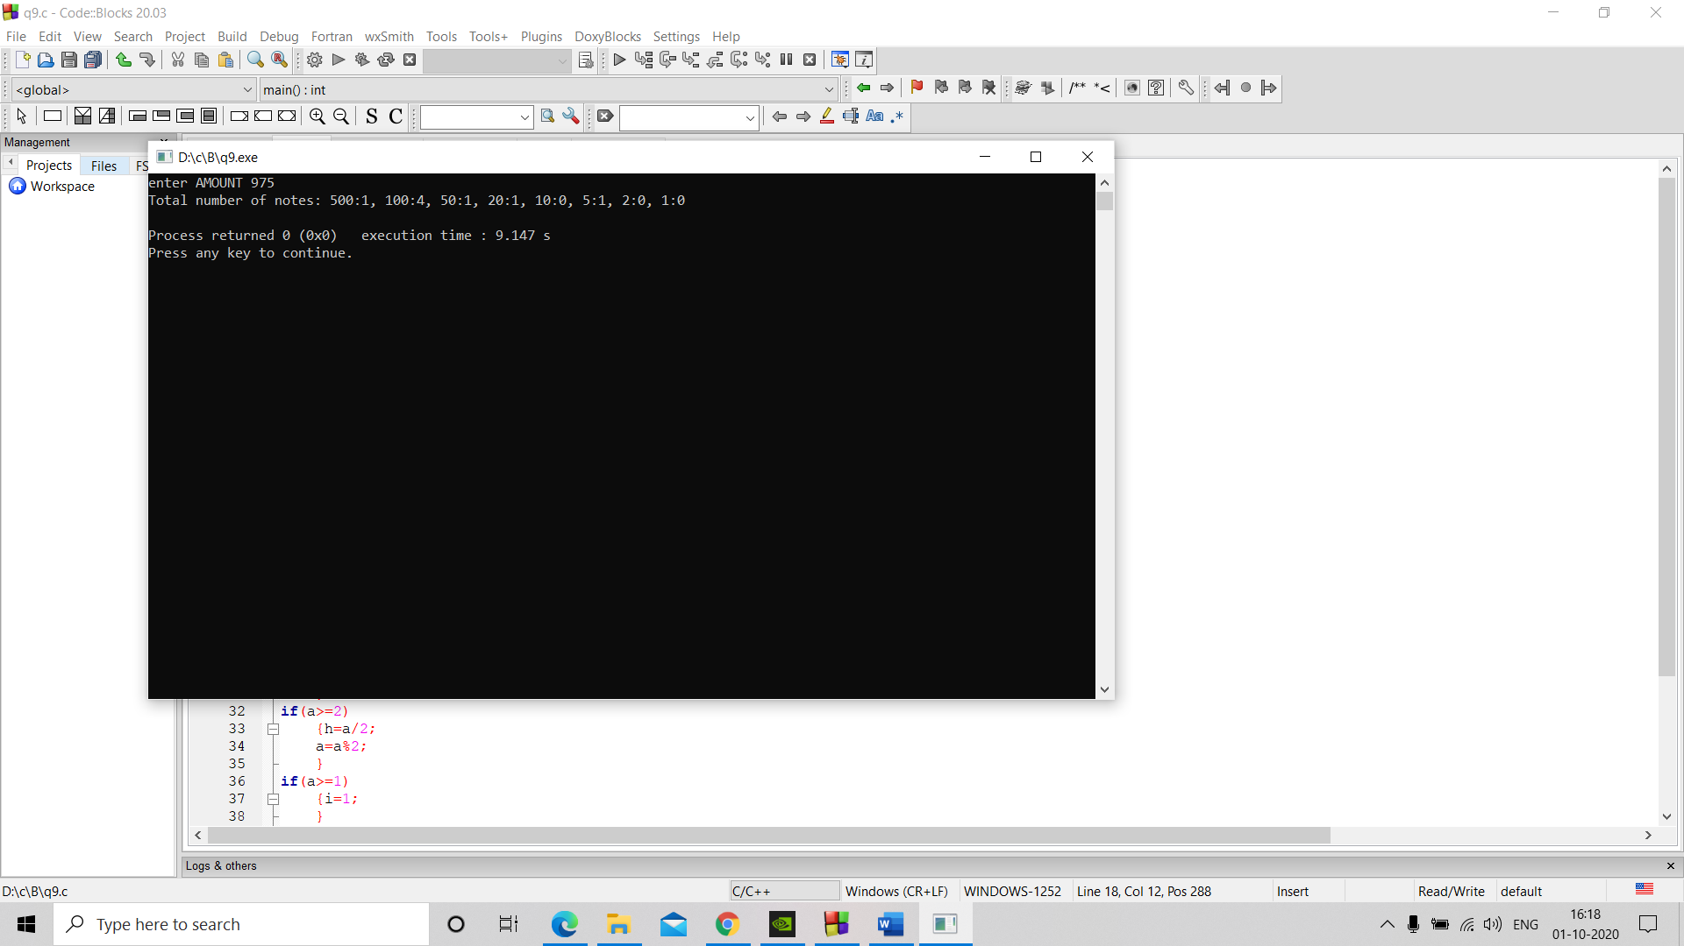int a,b=0,c=0,d=0,e=0,f=0,g=0,h=0,i=0;

printf("enter AMOUNT ");

scanf("%d",&a);

if(a>=500)

{b=a/500;

a=a%500;

}

if(a>=100)

{c=a/100;

a=a%100;

}

if(a>=50)

{d=a/50;

a=a%50;

}

if(a>=20)

{e=a/20;

a=a%20;

}

if(a>=10)

{f=a/10;

a=a%10;

}

if(a>=5)

{g=a/5;

a=a%5;

}

if(a>=2)

{h=a/2;

a=a%2;

}

if(a>=1)

{i=1;

}

printf("Total number of notes: 500:%d, ",b);

printf("100:%d, 50:%d, 20:%d, 10:%d, 5:%d, 2:%d, 1:%d \n ",c,d,e,f,g,h,i);

}

Q10.

#include<stdlib.h> //gross

#include<stdio.h>

int main()

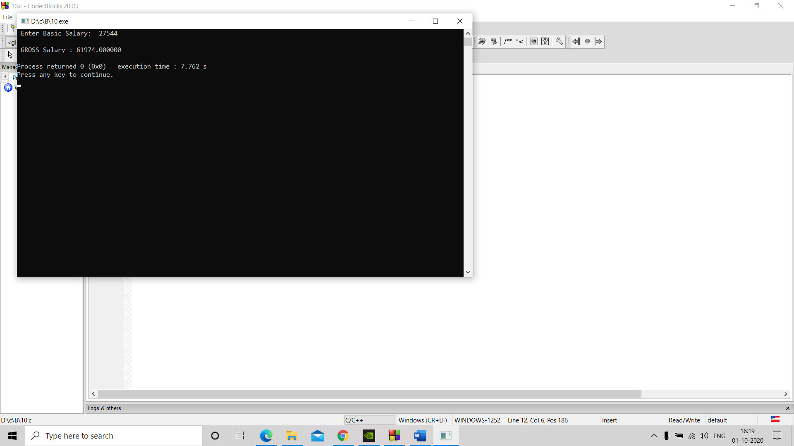{

float a,b,c,G;

printf(" Enter Basic Salary: ");

scanf("%f",&a);

if(a<=10000)

{b=0.2\*a;

c=0.8\*a;

}

else if(a>=10001 && a<=20000)

{b=0.25\*a;

c=0.9\*a;

}

else if(a>=20001)

{b=0.3\*a;

c=0.95\*a;

}

G=a+b+c;

printf("\n GROSS Salary : %f \n",G);

}